WEEK 6 ASSIGNMENT (DIGITAL NURTURE 4.0 JAVA FSE)

NAME: HARI PRASATH R

SUPERSET ID: 6397673

**My First React :**

**CODE:**

**App.js:**

import React from 'react';

function App() {

  return (

    <h1>Welcome to the first session of React</h1>

  );

}

export default App;

**Outputs:**

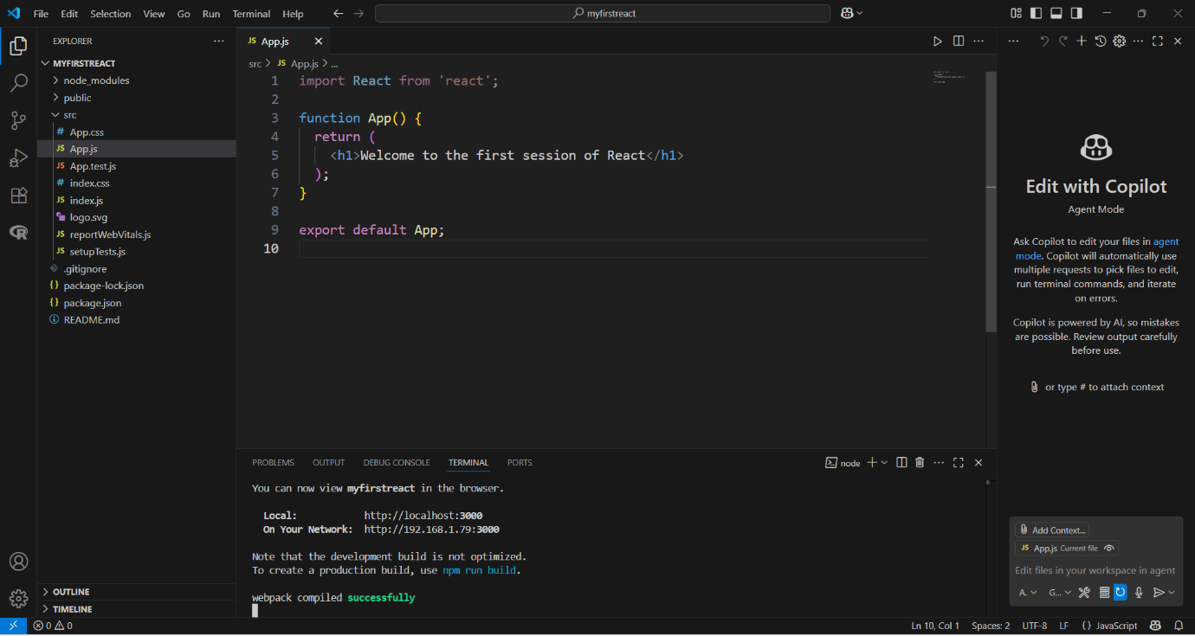

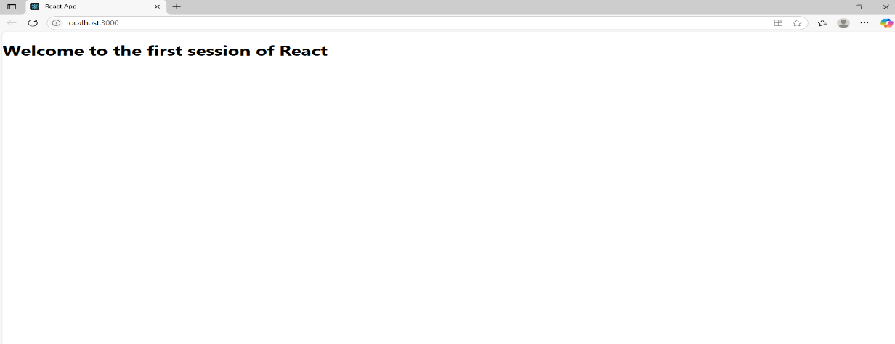

**Student Management Portal:**

**CODE:**

**App.js:**

import './App.css';

import { CalculateScore } from './Components/CalculateScore';

function App() {

  return (

    <div className="App">

      <CalculateScore />

    </div>

  );

}

export default App;

**CalculateScore.js:**

import React from "react";

import "../Stylesheets/mystyle.css";

export function CalculateScore() {

  const name = "Steeve";

  const school = "DNV Public School";

  const total = 284;

  const goal = 300;

  const score = ((total / goal) * 100).toFixed(2);

  return (

    <div className="score-container">

      <h2 className="title">Student Details:</h2>

      <p className="name">

        <span className="label">Name:</span> <span className="value"> {name}</span>

      </p>

      <p className="school">

        <span className="label">School:</span> <span className="value"> {school}</span>

      </p>

      <p className="total">

        <span className="label">Total:</span> <span className="value"> {total} Marks</span>

      </p>

      <p className="score">

        <span className="label">Score:</span> <span className="value"> {score}%</span>

      </p>

    </div>

  );

}

**mystyle.css:**

.score-container {

  background-color: #ffffff;

  margin: 50px auto;

  padding: 25px 35px;

  width: 440px;

  text-align: left;

  border: 1px solid #ccc;

  border-radius: 12px;

  font-family: Arial, sans-serif;

  font-size: 18px;

  box-shadow: 2px 2px 10px rgba(0, 0, 0, 0.1);

}

.title {

  text-align: center;

  color: #d32f2f; /* red for title */

  margin-bottom: 20px;

  font-size: 22px;

  font-weight: bold;

}

/* Name */

.name .label {

  color: #0a3d91; /* slightly darker blue */

  font-weight: 600;

}

.name .value {

  color: #2196f3; /* normal blue */

}

/* School */

.school .label {

  color: #a01e1e; /* slightly darker red */

  font-weight: 600;

}

.school .value {

  color: #f28b82; /* light red */

}

/* Total */

.total .label {

  color: #6a1b9a; /* deeper violet */

  font-weight: 600;

}

.total .value {

  color: #c084f2; /* light violet */

}

/* Score */

.score .label {

  color: #1b5e20; /* deeper green */

  font-weight: 600;

}

.score .value {

  color: #81c784; /* light green */

}

**Outputs:**

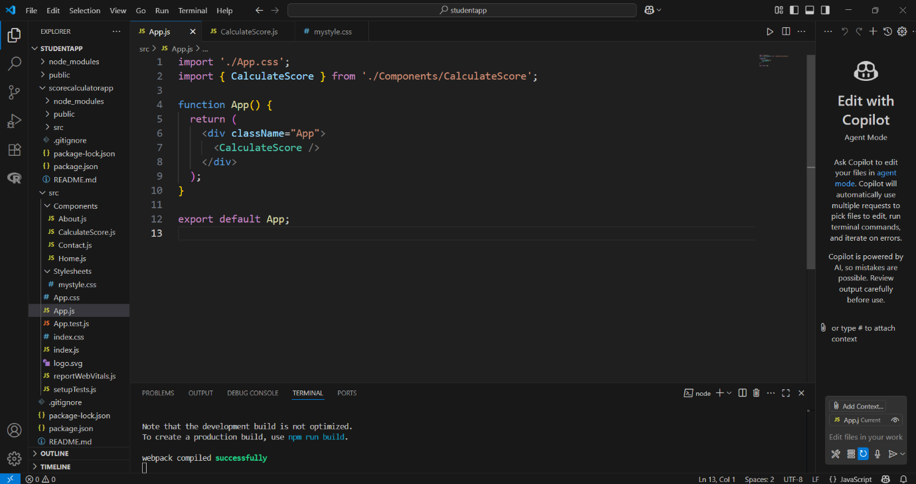

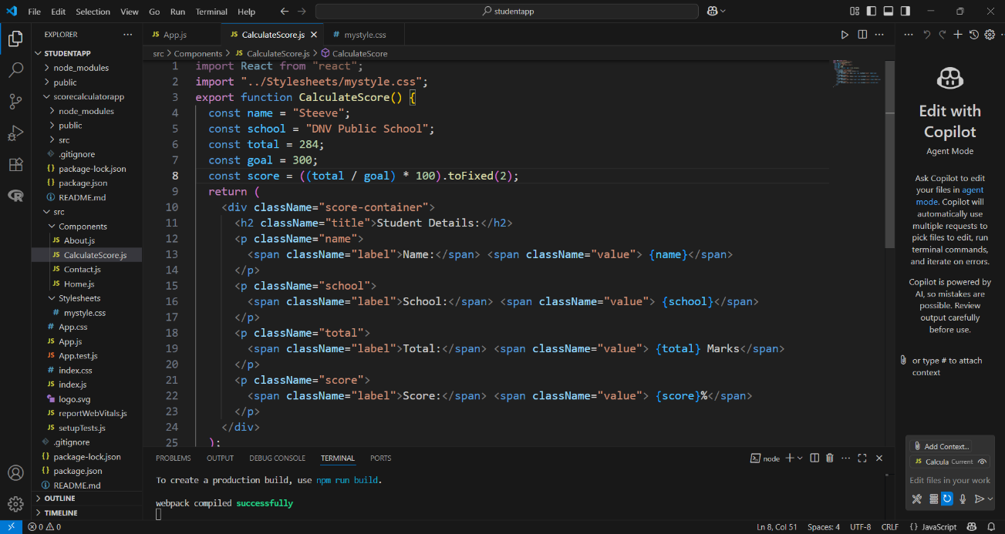

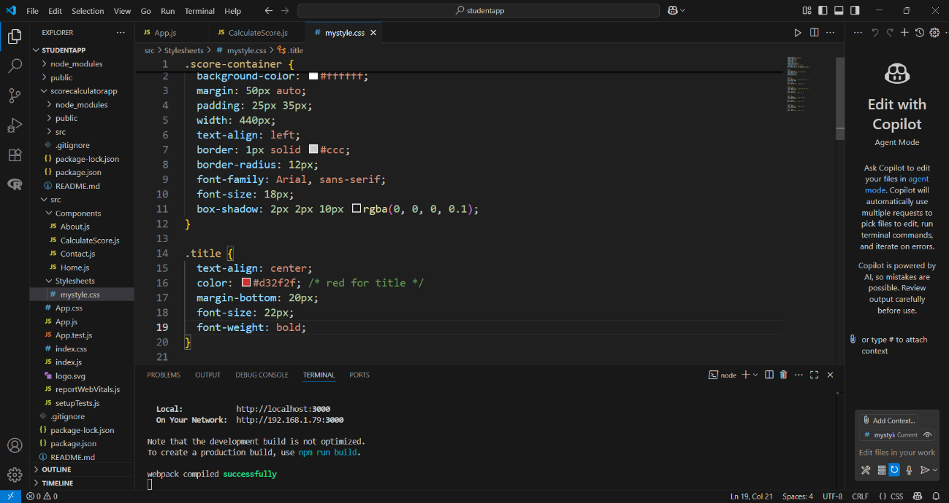

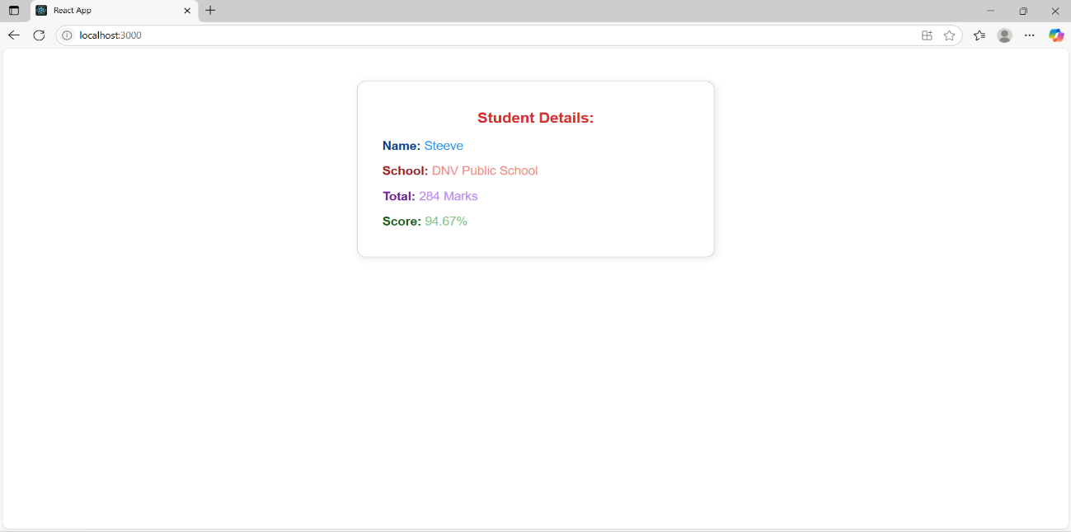

**Student Management Portal:**

**CODE:**

**App.js:**

import './App.css';

import Home from './Components/Home';

import About from './Components/About';

import Contact from './Components/Contact';

function App() {

  return (

    <div className="container">

      <Home />

      <About />

      <Contact />

    </div>

  );

}

export default App;

**App.css:**

.App {

  text-align: center;

}

.App-logo {

  height: 40vmin;

  pointer-events: none;

}

@media (prefers-reduced-motion: no-preference) {

  .App-logo {

    animation: App-logo-spin infinite 20s linear;

  }

}

.App-header {

  background-color: #282c34;

  min-height: 100vh;

  display: flex;

  flex-direction: column;

  align-items: center;

  justify-content: center;

  font-size: calc(10px + 2vmin);

  color: white;

}

.App-link {

  color: #61dafb;

}

@keyframes App-logo-spin {

  from {

    transform: rotate(0deg);

  }

  to {

    transform: rotate(360deg);

  }

}

.centered {

  text-align: center;

  margin-top: 30px;

  font-size: 24px;

  font-weight: bold;

  color: #333;

}

**Home.js:**

function Home() {

  return (

    <div className="centered">

      <h2>Welcome to Home Page of Student Management Portal</h2>

    </div>

  );

}

export default Home;

**About.js:**

function About() {

  return (

    <div className="centered">

      <h2>Welcome to About Page of Student Management Portal</h2>

    </div>

  );

}

export default About;

**Contact.js:**

function Contact() {

  return (

    <div className="centered">

      <h2>Welcome to Contact Page of Student Management Portal</h2>

    </div>

  );

}

export default Contact;

**Outputs:**

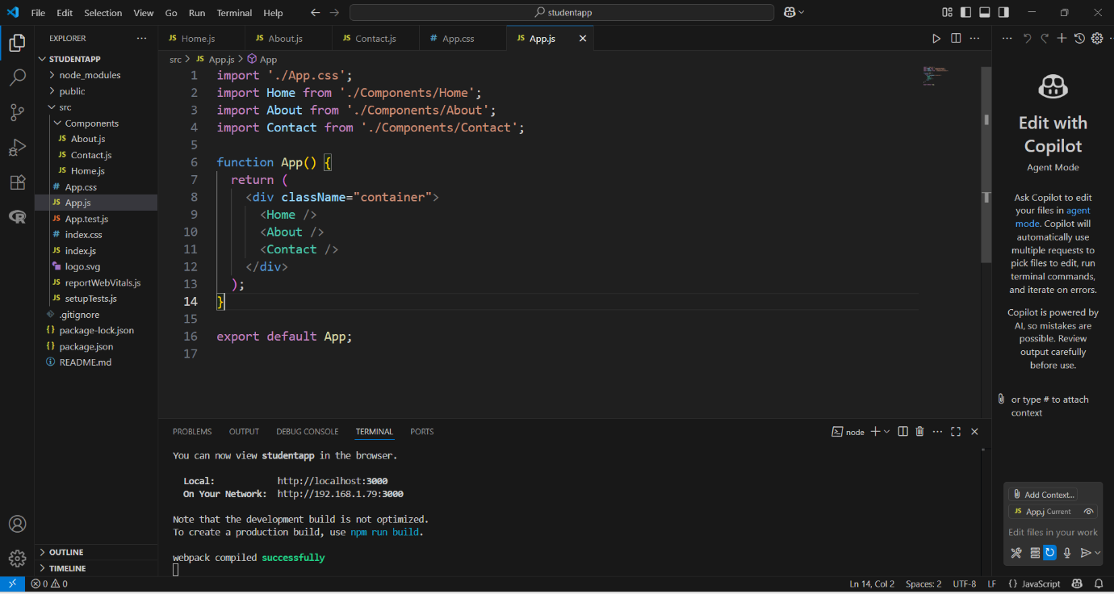

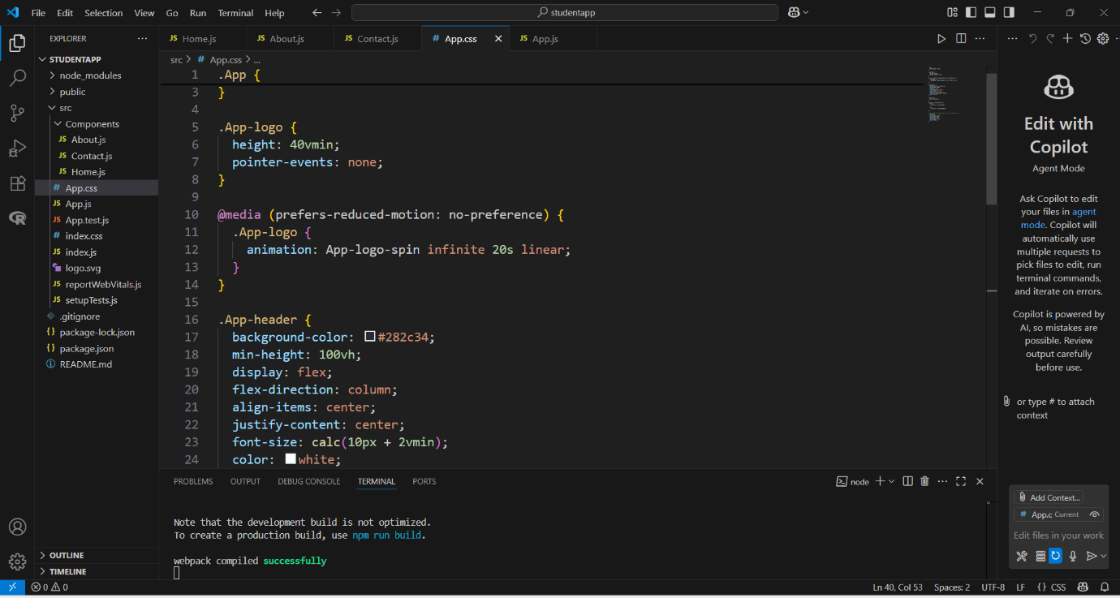

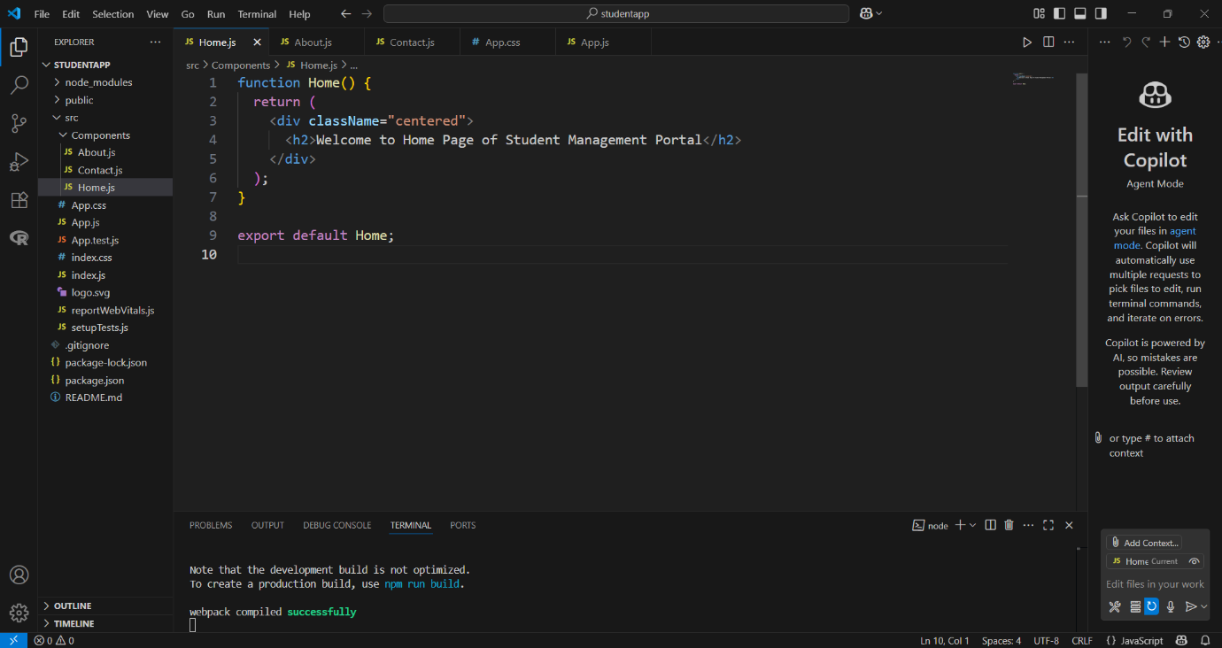

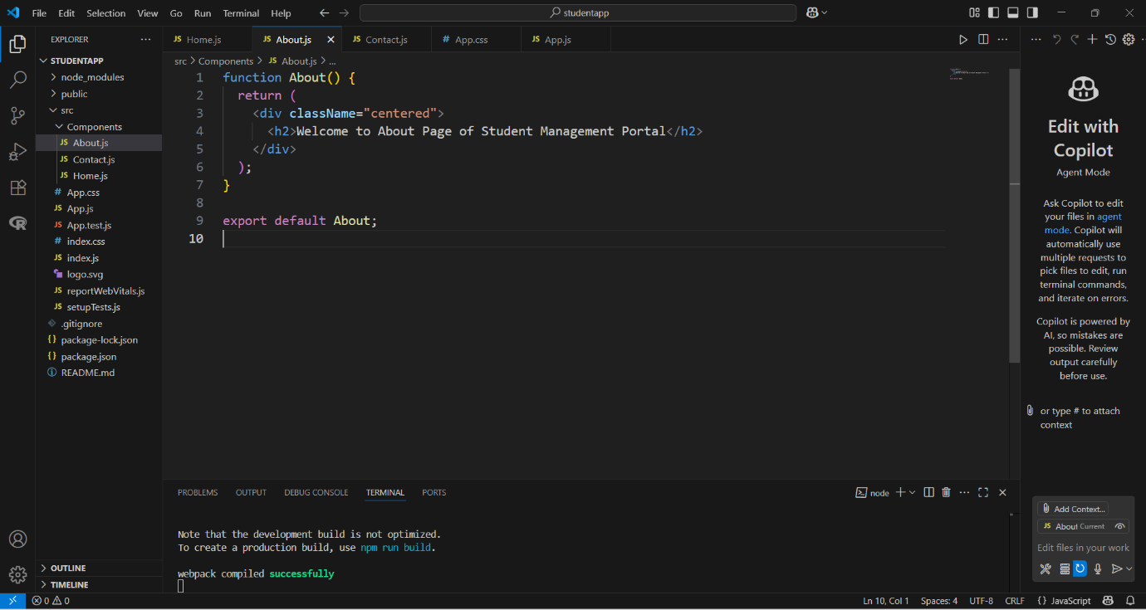

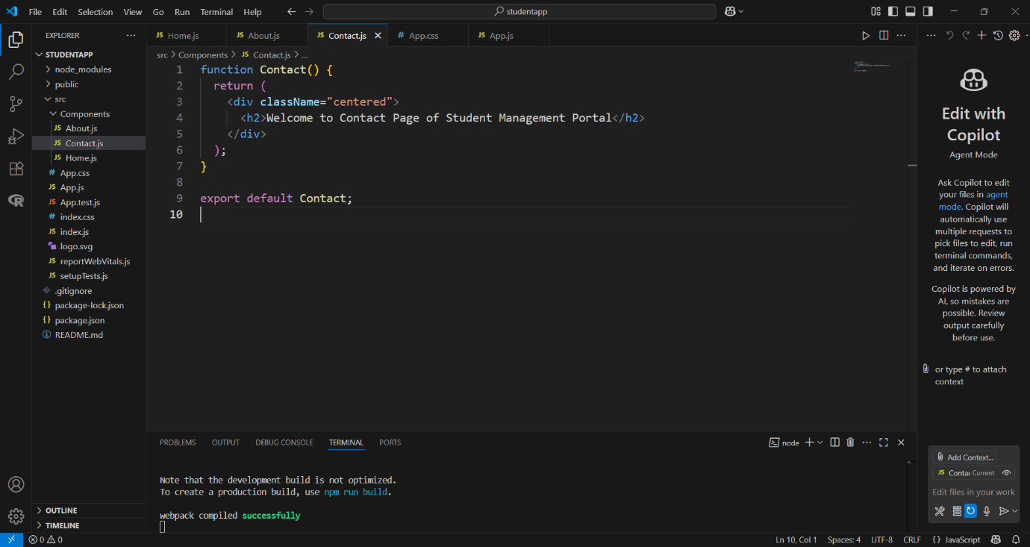

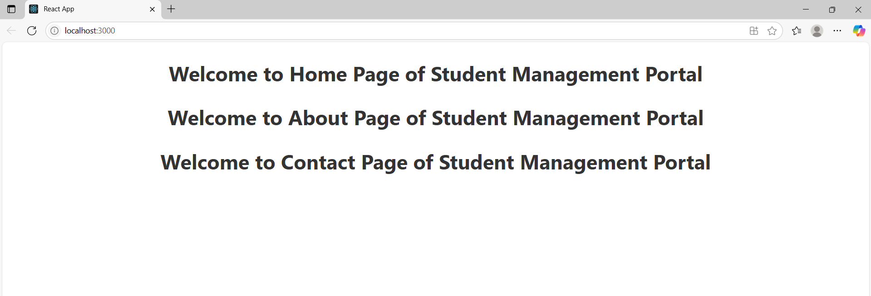

**Cohort Details:**

**CODE:**

**App.js:**

import React from 'react';

import Dashboard from './Dashboard';

function App() {

  return (

    <div>

      <Dashboard />

    </div>

  );

}

export default App;

**Dashboard.jsx:**

import React from 'react';

import CohortDetails from './components/CohortDetails';

const cohortData = [

  {

    title: "INTADMDF10-.NET FSD",

    startDate: "22-Feb-2022",

    status: "Scheduled",

    coach: "Aathma",

    trainer: "Jojo Jase"

  },

  {

    title: "ADM21JF014 - Java FSD",

    startDate: "10-Sep-2021",

    status: "Ongoing",

    coach: "Apoorv",

    trainer: "Elisa Smith"

  },

  {

    title: "CDBJF21025-Java FSD",

    startDate: "24-Dec-2021",

    status: "Ongoing",

    coach: "Aathma",

    trainer: "John Doe"

  }

];

const Dashboard = () => {

  return (

    <div>

      <h2>Cohorts Details</h2>

      {cohortData.map((cohort, index) => (

        <CohortDetails key={index} cohort={cohort} />

      ))}

    </div>

  );

};

export default Dashboard;

**CohortDetails.jsx:**

import React from 'react';

import styles from './CohortDetails.module.css';

const CohortDetails = ({ cohort }) => {

  const isGreenTitle = cohort.title.startsWith('ADM') || cohort.title.startsWith('CDB');

  return (

    <div className={styles.box}>

      <h3 style={{ color: isGreenTitle ? 'green' : 'blue' }}>

        {cohort.title}

      </h3>

      <dl>

        <dt>Started On</dt>

        <dd>{cohort.startDate}</dd>

        <dt>Current Status</dt>

        <dd>{cohort.status}</dd>

        <dt>Coach</dt>

        <dd>{cohort.coach}</dd>

        <dt>Trainer</dt>

        <dd>{cohort.trainer}</dd>

      </dl>

    </div>

  );

};

export default CohortDetails;

**CohortDetails.module.css:**

.box {

  width: 300px;

  display: inline-block;

  margin: 10px;

  padding: 10px 20px;

  border: 1px solid black;

  border-radius: 10px;

}

dt {

  font-weight: 500;

}

**Outputs:**

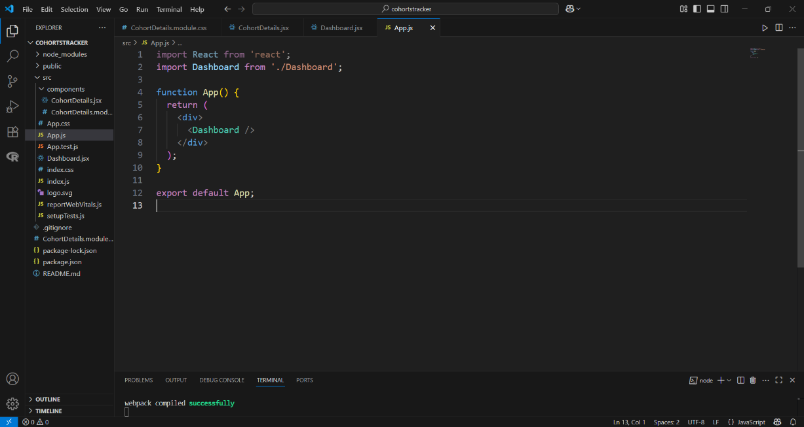

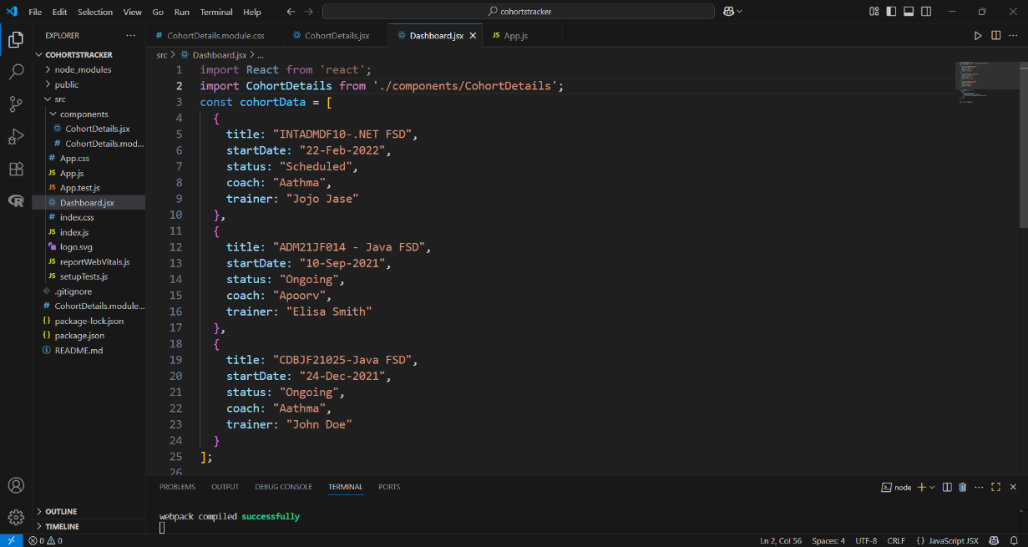

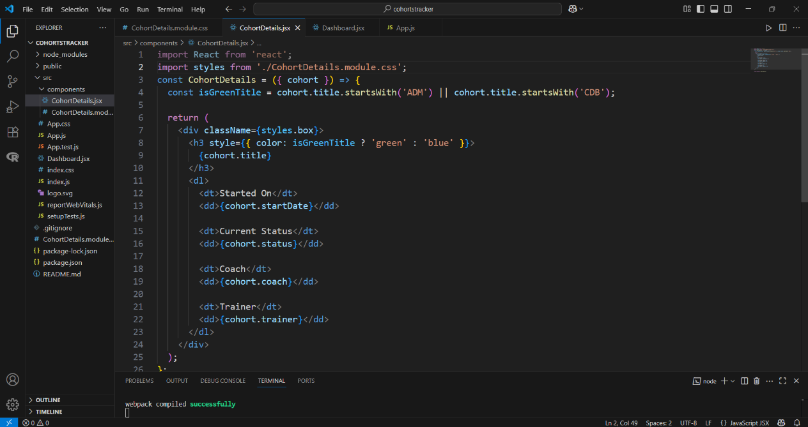

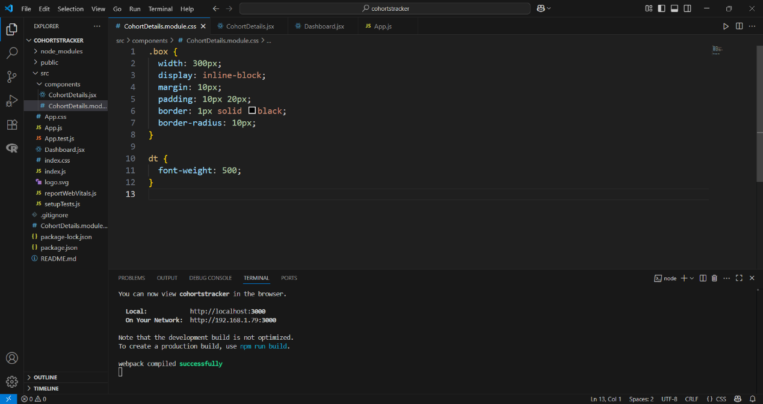

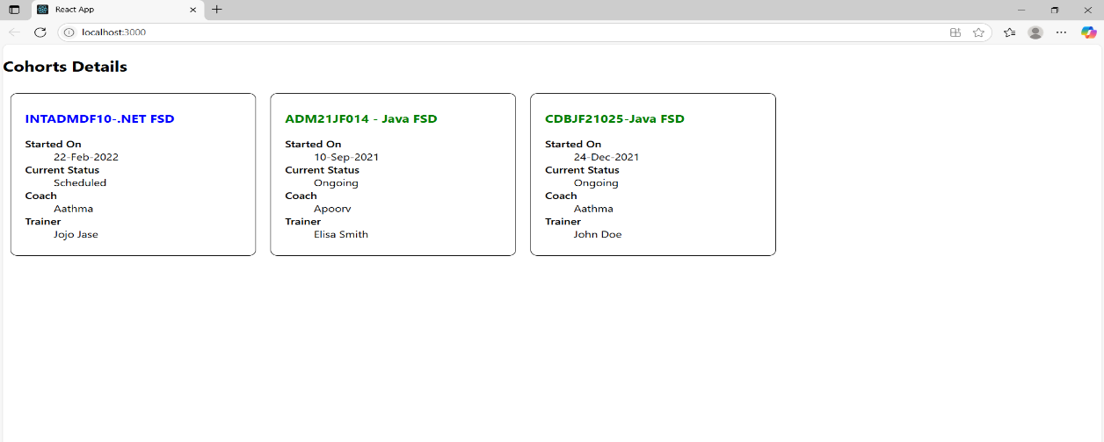

**Create-react-app:**

**CODE:**

**App.js:**

import React from 'react';

import './App.css';

import Posts from './Posts';

function App() {

  return (

    <div className="App">

      <Posts />

    </div>

  );

}

export default App;

**Post.js:**

class Post {

  constructor(id, title, body) {

    this.id = id;

    this.title = title;

    this.body = body;

  }

}

export default Post;

**Posts.js:**

// JS Posts.js UX

import React from 'react';

class Posts extends React.Component {

  constructor(props) {

    super(props);

    this.state = {

      posts: []

    };

  }

  loadPosts() {

    fetch('https://jsonplaceholder.typicode.com/posts')

      .then((response) => response.json())

      .then((data) => {

        this.setState({ posts: data });

      })

      .catch((error) => {

        console.error('Error fetching posts:', error);

      });

  }

  componentDidMount() {

    this.loadPosts();

  }

  render() {

    return (

      <div>

        <h1>Posts</h1>

        {this.state.posts.map(post => (

          <div key={post.id}>

            <h2>{post.title}</h2>

            <p>{post.body}</p>

            <hr />

          </div>

        ))}

      </div>

    );

  }

  componentDidCatch(error, info) {

    alert("An error occurred: " + error.message);

    console.error("Error details:", info);

  }

}

export default Posts;

**Outputs:**

